Request for Proposal

Industrial Cooler – Food Bank Operations

Community Action Partnership of San Bernardino County

DUE DATE FOR SUBMISSION:
Friday, October 16, 2020
Submission Due Date Extended to
Wednesday September 21, 2020

Community Action Partnership of San Bernardino County Contact person: Brandon Romano, Program Manager II
Bromano@CAPSBC.org
696 S. Tippecanoe Avenue San Bernardino, CA 92408-2607 Phone Number: (909) 723-1581

Table of Contents
Purpose of Request 2
Questions & Clarifications 2
Submission Deadline… 2
Submission Delivery Address 2
Schedule of RFP 2
Detailed Scope of Services 2-3
Selection Criteria 4
Right to Change RFP and Process 4
Solicitation Caveat 4
Exhibit A: Warehouse Layout 5
Exhibit B: Recommended Submission Template 6-7

Purpose of Request
Community Action Partnership of San Bernardino County (CAPSBC) is a 501(c)(3) nonprofit organization serving San Bernardino County since 1965. CAPSBC works with our low-income communities by supporting, advocating for and empowering low-income residents to achieve self-sufficiency.
CAPSBC is seeking proposals for the installation of an industrial cooler for CAPSBC’s Food Bank program. The purpose of the Request for Proposal (RFP) is to solicit competitive bids to identify vendors that are well qualified, professional, and have the capacity to meet the needs of our organization at a competitive cost.

Questions & Clarifications
The following contact is to be used for all questions and clarifications:

Brandon Romano, Program Manager II
Community Action Partnership of San Bernardino County 696 S. Tippecanoe Ave.
San Bernardino, CA 92408
Office: (909) 723-1581
Email: Bromano@capsbc.org

Submission Deadline
Submissions may be submitted electronically or US mail. The submission deadline is Wednesday, October 21, 2020 no later than 5:00pm.

Submission Delivery Address
Bromano@capsbc.org
Or
Community Action Partnership of San Bernardino County Attention: Brandon Romano
696 S. Tippecanoe Ave.
San Bernardino, CA 92408

Schedule of RFP
CAPSBC will maintain the following timeline in selecting a qualified organization that can meet our needs:

Issued Request for Proposal October 16, 2020 Deadline for Submission of Proposals October 21, 2020
RFP Anticipated Award Notification October 23, 2020

Proposal Requirements
All bidders must include in their proposal the following information:
- Cover Page of Proposal – Provide agency contact information to include, name, address, telephone number, website, email address, and primary person of contact.

- Summary – Provide a summary of your company signed by the person authorized to represent the organization. Please include any information about your organization’s commitment to the nonprofit sector if applicable.
- Project Specifications – The following product specs are not exclusive to the desired final product, but are based upon CAPSBC projected specifications:
- Industrial Cooler
  - Estimated size specifications: 20’x37’ (740sqft)
  - Estimated height: 12.5’
  - Holding Temperature: 38 Fahrenheit
- Requested Features
  - Vapor curtain
  - Protective bollards
  - Interior wall protection
  - LED covered lighting
  - Two shelf pallet racking along interior perimeter
- Additional Notes and Inclusions
  - Condenser to be placed on warehouse roof
  - Demolition and removal of existing cooler unit
  - Proposal is to include costs for permitting, fees, taxes, engineering costs, and any other applicable costs

- Timeline – Please provide an anticipated project schedule.

- Total Cost – A budget needs to be provided outlining the proposed cost for project. The proposal should represent the final pricing including additional fees, discounts, shipping, permits, and taxes.

- Capability Statement – Document of your business competencies. CAPSBC shall have the sole and exclusive right to determine whether a bidder has the qualifications to provide the services required by this RFP. The submitted proposal is to include:
  - Company Data – Include a brief summary of your company, background, including number of employees and capacity. Also list DUNS, CAGE Code, NAICS codes.
  - Core Competencies – Provide your organization’s relevant experience – e.g., previous projects of similar nature, staff’s years of experience, stakeholders, client base, communities served, and/or quality services model.
  - References – The bidder must submit 3 references. CAPSBC may contact these references and/or other entities or persons to verify, clarify, or obtain additional information.
  - Contact information – Provide bidder contact information, including website and primary contact.
  - Additional Documentation and Information – CAPSBC may request from any bidder clarification or additional information or documentation regarding or relating to the qualifications to perform the required services, as well as any other information pertinent to the agency’s response to the RFP. Upon CAPSBC’s request, an agency shall promptly submit to CAPSBC such additional information or documentation. An agency’s failure or refusal to submit any clarification, information, or documentation requested by CAPSBC may result in CAPSBC’s rejection of the response to the RFP.

Selection Criteria
Proposals will be evaluated on the following factors:

Factors | Weight
A. Response of the written proposal to the scope of services, overall service approach, qualifications, experience, and references. Ability and history of successfully completing contracts of this type, and experience in similar projects. | 30%
B. Project Timeline to completion, meeting projected deadlines | 20%
C. Cost of product services and product warranty. | 50%
 | 100%

Award Eligibility

CAPSBC verifies all bidder eligibility to receive Federal contracts using the System for Award Management (SAM). All bidders will be verified in www.SAM.gov for active registration and to ensure the bidder does not have an active exclusion.

Right to Change RFP and Process
CAPSBC reserves the right to accept or reject any and all submissions, in whole or in part, to advertise for new submissions, to abandon the need for services and to cancel or amend this RFP at any time. CAPSBC reserves the right to waive any formalities or minor deficiencies in the RFP process, consistent with CAPSBC’s best interest.

Solicitation Caveat
Bidders understand and agree that CAPSBC shall have no financial responsibility for any costs incurred in responding to this RFP and shall not be liable for any costs until the bidder has executed a contract with CAPSBC and has been authorized in writing to proceed. CAPSBC reserves the right to terminate this RFP. The submission of a proposal shall be conclusive evidence that the bidder has investigated and understands, to its own satisfaction, the conditions to be encountered, the character, quality and scope of work to be performed, the requirements of CAPSBC and the applicable regulations as set forth in this RFP.

Exhibit A: Warehouse Layout and Proposed Cooler Placement

The red section displays the proposed installation and layout of the cooler project for reference.
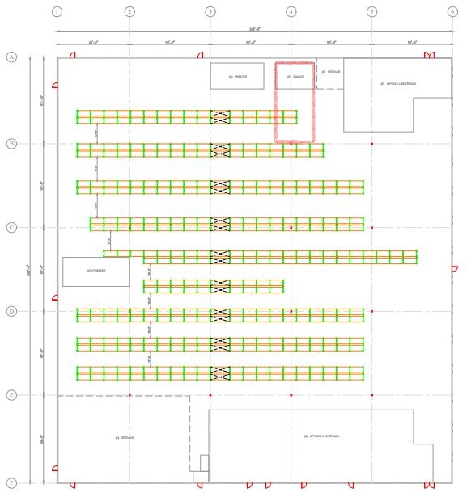

Exhibit B: Recommended Submission Format/Template

It is recommended that all bidders submit their proposals using the following template and attach any all required and additional information.

SECTION A: BIDDER INFORMATION AND CONTACT

Full Legal Name of Bidder:

Any DBA name(s):

Federal EIN:

DUNS/CAGE:

Business Address:

Business Phone No.:

Name and Title of Person Completing Proposal:

Primary Contact Email:
Primary Contact Phone:
Company Data/Background:
Proposal Summary:

SECTION B: EXPERIENCE, PERFORMANCE, AND REFERENCE
Describe bidder’s business and operations within the last 5 years.

Describe the team that will be responsible for providing services to CAPSBC.

Please list contact information for at least three clients for whom bidder has provided services. CAPSBC may contact these references and/or other entities or persons to verify, clarify, or obtain additional information. Bidder hereby authorizes CAPSBC to contact such clients regarding the services that bidder provided to them.

In the past 10 years, has bidder or any of bidder’s owners, officers, or partners been found liable in a civil suit or found guilty in a criminal action for making any false claim or material misrepresentation to any agency? If yes, explain.

Explain bidder’s process for managing and resolving complaints for all parties involved.

Has the organization ever been banned from doing business with the federal government?

SECTION C: VERIFICATION

I, the undersigned, hereby certify and declare that I have read all of the answers to this questionnaire and know their contents. The matters stated in such answers are true and correct of my own knowledge and belief. I certify and declare that the stated and provided information is true and correct of my knowledge.

This must only be signed by the individual authorized to commit the entity.

Signature
Print Name
Title
Date

SECTION D: Project Quote and Specifications Attachment

SECTION E: Estimated Project Fulfillment Timeline

SECTION F: Optional or Additional Attachments
    - Credit Application
    - Contract/MOU
    - Warranty Information
    - Other Applicable Information or Documents

